Semicylinder

Definition
# Source: AI Source: Provided by: [Data Path: Persons Table -> ID Column: 1, Name_En Column: Motasem Essam] -> From: [ChatGPT] on [7/25/2026]
A Semicylinder is a three-dimensional geometric solid formed by dividing a right circular cylinder into two equal halves along a plane passing through its central axis.
Each half has:
- One semicircular flat base.
- One semicircular flat top.
- One rectangular flat face created by the longitudinal cut.
- One curved lateral surface.
A semicylinder represents exactly half of the original cylinder's volume.

Main Elements of a Semicylinder
# Source: AI Source: Provided by: [Data Path: Persons Table -> ID Column: 1, Name_En Column: Motasem Essam] -> From: [ChatGPT] on [7/25/2026]
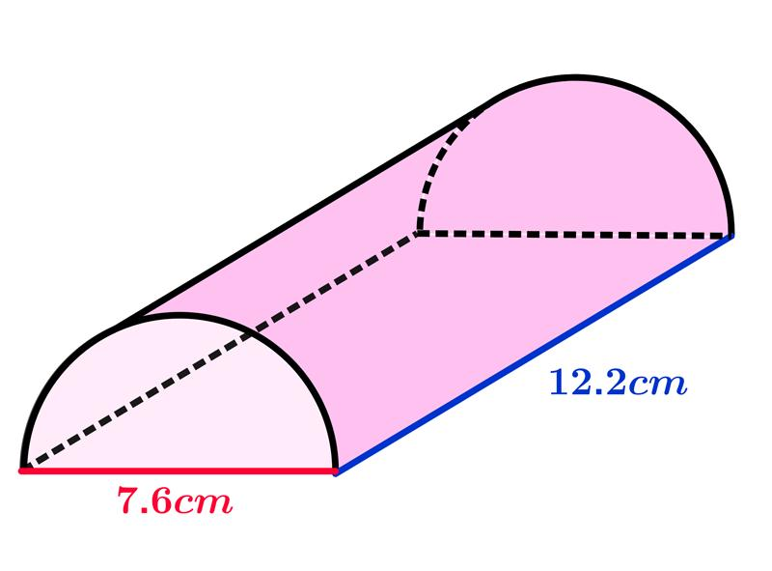
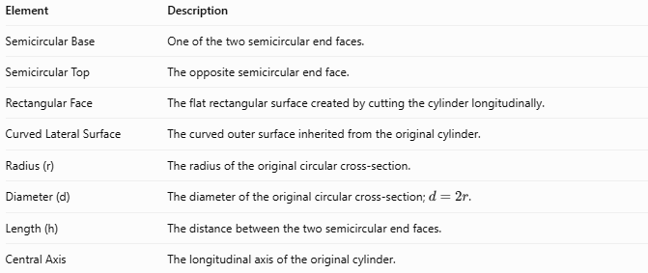
Element | Description
Semicircular Base | One of the two semicircular end faces.
Semicircular Top | The opposite semicircular end face.
Rectangular Face | The flat rectangular surface created by cutting the cylinder longitudinally.
Curved Lateral Surface | The curved outer surface inherited from the original cylinder.
Radius (r) | The radius of the original circular cross-section.
Diameter (d) | The diameter of the original circular cross-section; $d=2r$.
Length (h) | The distance between the two semicircular end faces.
Central Axis | The longitudinal axis of the original cylinder.

Mathematical Properties
# Source: AI Source: Provided by: [Data Path: Persons Table -> ID Column: 1, Name_En Column: Motasem Essam] -> From: [ChatGPT] on [7/25/2026]
Let:
- $r$ = radius.
- $h$ = length (height).

Volume
# Source: AI Source: Provided by: [Data Path: Persons Table -> ID Column: 1, Name_En Column: Motasem Essam] -> From: [ChatGPT] on [7/25/2026]
The volume is half the volume of the corresponding cylinder.
$$V=\frac{1}{2}πr^{2}h$$

Surface Area
# Source: AI Source: Provided by: [Data Path: Persons Table -> ID Column: 1, Name_En Column: Motasem Essam] -> From: [ChatGPT] on [7/25/2026]
The total surface area consists of three parts:

Curved Surface Area
# Source: AI Source: Provided by: [Data Path: Persons Table -> ID Column: 1, Name_En Column: Motasem Essam] -> From: [ChatGPT] on [7/25/2026]
$$CSA=πrh$$

Area of the Two Semicircular Faces
# Source: AI Source: Provided by: [Data Path: Persons Table -> ID Column: 1, Name_En Column: Motasem Essam] -> From: [ChatGPT] on [7/25/2026]
$$A=πr^{2}$$

Rectangular Face Area
# Source: AI Source: Provided by: [Data Path: Persons Table -> ID Column: 1, Name_En Column: Motasem Essam] -> From: [ChatGPT] on [7/25/2026]
$$A=2rh$$
Total Surface Area
$$TSA=πrh+πr^{2}+2rh$$

Base Area
# Source: AI Source: Provided by: [Data Path: Persons Table -> ID Column: 1, Name_En Column: Motasem Essam] -> From: [ChatGPT] on [7/25/2026]
The area of each semicircular end is:
$$A=\frac{1}{2}πr^{2}$$

Constructing a Semicylinder

Geometric Instruments
# Source: AI Source: Provided by: [Data Path: Persons Table -> ID Column: 1, Name_En Column: Motasem Essam] -> From: [ChatGPT] on [7/25/2026]
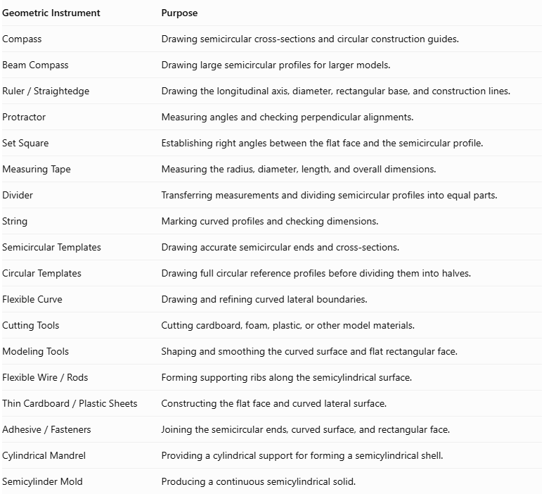
Geometric Instrument | Purpose
Compass | Drawing semicircular cross-sections and circular construction guides.
Beam Compass | Drawing large semicircular profiles for larger models.
$$Ruler/Straightedge$$ | Drawing the longitudinal axis, diameter, rectangular base, and construction lines.
Protractor | Measuring angles and checking perpendicular alignments.
Set Square | Establishing right angles between the flat face and the semicircular profile.
Measuring Tape | Measuring the radius, diameter, length, and overall dimensions.
Divider | Transferring measurements and dividing semicircular profiles into equal parts.
String | Marking curved profiles and checking dimensions.
Semicircular Templates | Drawing accurate semicircular ends and cross-sections.
Circular Templates | Drawing full circular reference profiles before dividing them into halves.
Flexible Curve | Drawing and refining curved lateral boundaries.
Cutting Tools | Cutting cardboard, foam, plastic, or other model materials.
Modeling Tools | Shaping and smoothing the curved surface and flat rectangular face.
$$FlexibleWire/Rods$$ | Forming supporting ribs along the semicylindrical surface.
$$ThinCardboard/PlasticSheets$$ | Constructing the flat face and curved lateral surface.
$$Adhesive/Fasteners$$ | Joining the semicircular ends, curved surface, and rectangular face.
Cylindrical Mandrel | Providing a cylindrical support for forming a semicylindrical shell.
Semicylinder Mold | Producing a continuous semicylindrical solid.
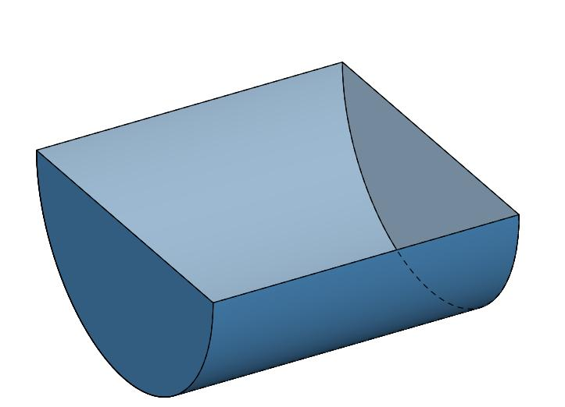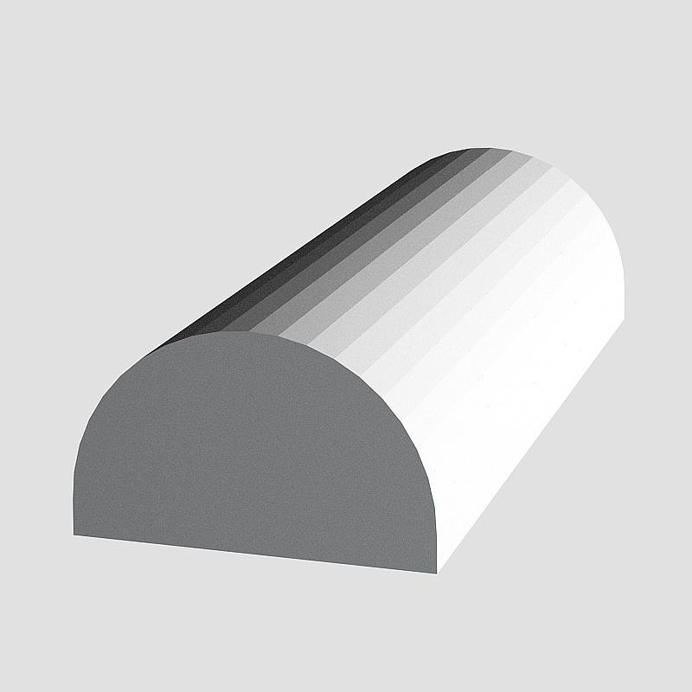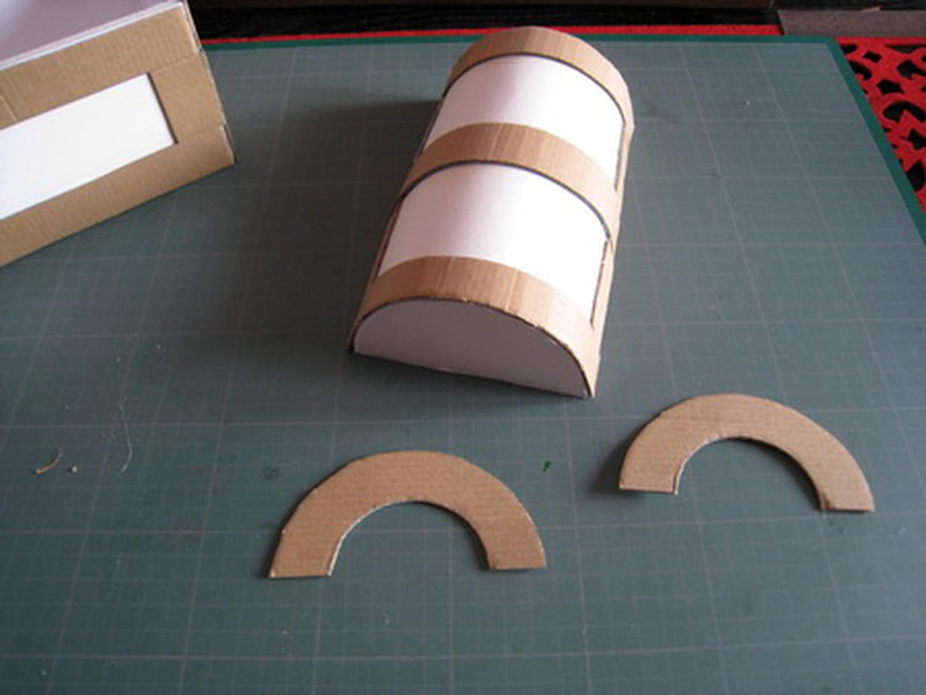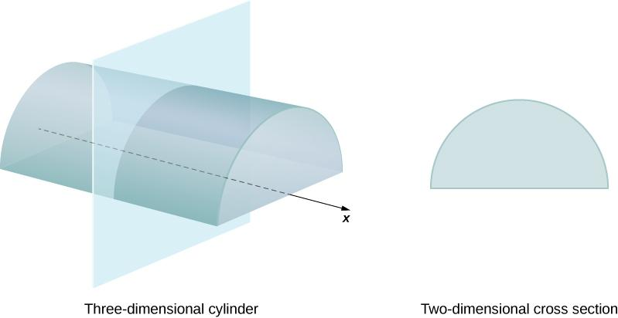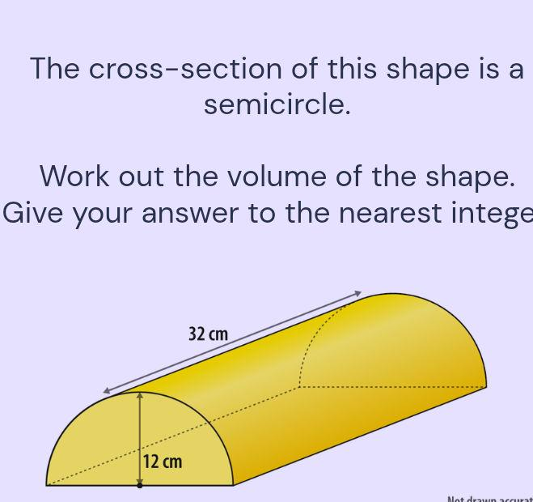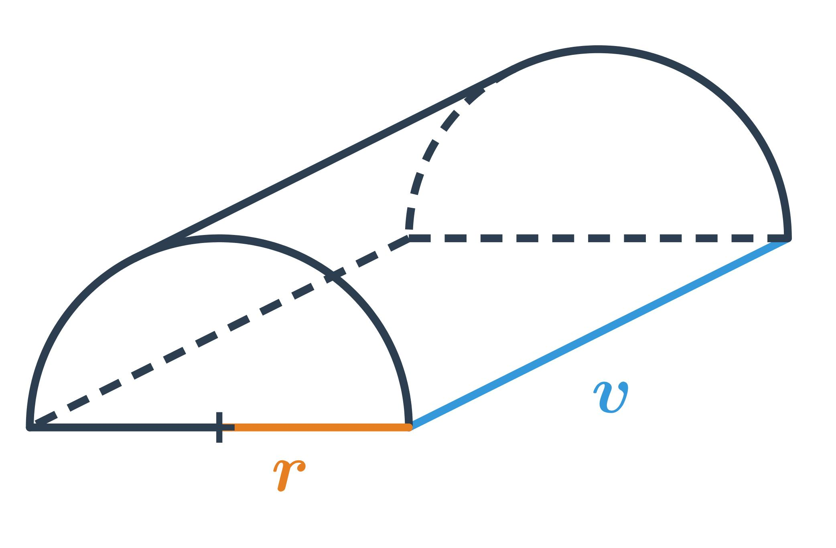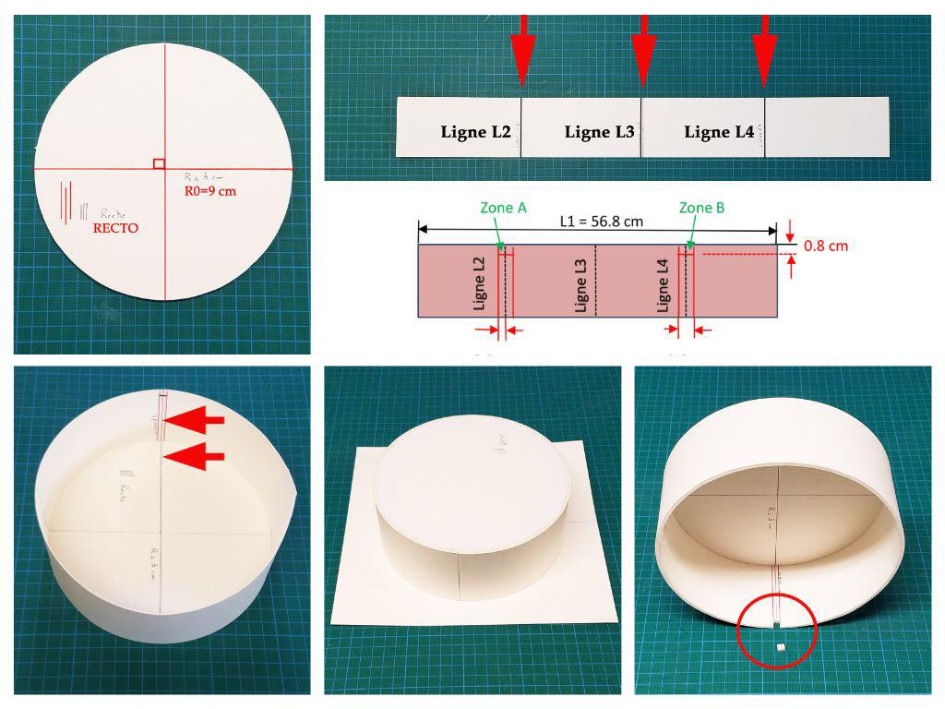

Instrument-Based Construction Procedures

Construction Using a Semicircular Cross-Section and Rectangular Face
# Source: AI Source: Provided by: [Data Path: Persons Table -> ID Column: 1, Name_En Column: Motasem Essam] -> From: [ChatGPT] on [7/25/2026]
- Draw a horizontal line representing the diameter of the semicircular cross-section.
- Mark its midpoint using a ruler and divider.
- Set the compass to the required radius.
- Draw a semicircle above the diameter.
- Prepare two identical semicircular templates for the two ends of the semicylinder.
- Draw a rectangle whose length equals the required semicylinder length and whose width equals the semicircle's diameter.
- Cut out the two semicircular ends and the rectangular face.
- Prepare a curved rectangular sheet with a length equal to the semicylinder length and a width equal to half the circumference of the original cylinder.
- Attach the curved sheet along the semicircular edges of both end pieces.
- Attach the rectangular face along the two straight longitudinal edges.
- Secure all connections using adhesive or fasteners.
- Inspect the finished semicylinder and smooth its surfaces.
This method constructs a closed semicylindrical solid with one flat rectangular face, one curved lateral surface, and two semicircular end faces.

Construction Using a Complete Cylinder and Longitudinal Cutting
# Source: AI Source: Provided by: [Data Path: Persons Table -> ID Column: 1, Name_En Column: Motasem Essam] -> From: [ChatGPT] on [7/25/2026]
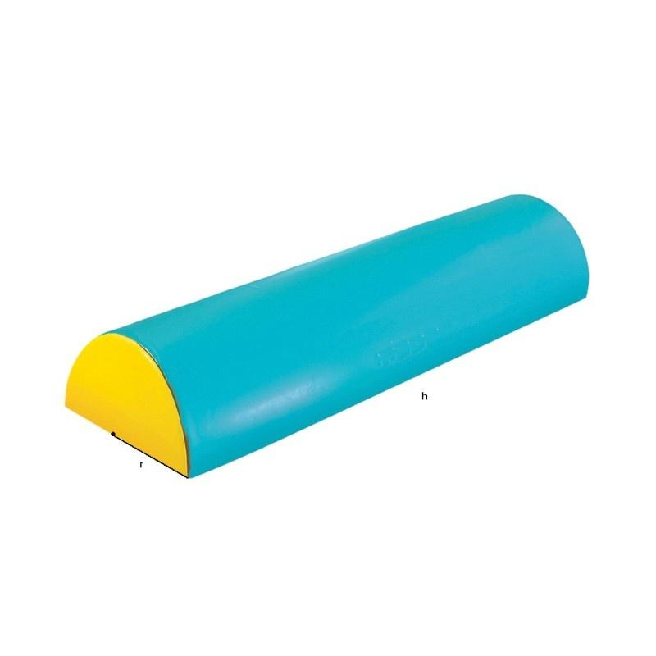
- Construct a complete right circular cylinder using cardboard, foam, clay, or another suitable material.
- Mark the central longitudinal axis of the cylinder.
- Draw a cutting plane passing through the central axis and both circular bases.
- Extend the cutting-plane markings along the entire cylinder.
- Secure the cylinder on a stable cutting surface.
- Cut the cylinder longitudinally along the marked plane.
- Separate the two resulting halves carefully.
- Select one half as the required semicylinder.
- Smooth the newly exposed rectangular face.
- Check that the two end faces are semicircles and that the longitudinal flat face passes through the cylinder axis.
This method produces two equal semicylinders from one complete right circular cylinder.

Construction Using Semicircular Cross-Sections
# Source: AI Source: Provided by: [Data Path: Persons Table -> ID Column: 1, Name_En Column: Motasem Essam] -> From: [ChatGPT] on [7/25/2026]
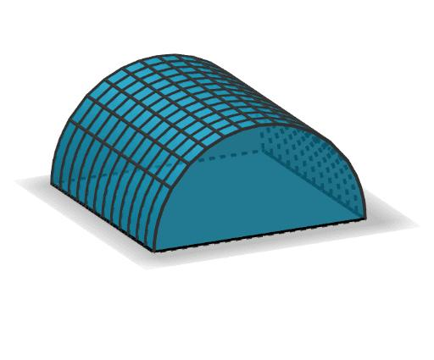
- Draw the required semicircular end profile using a compass.
- Mark the diameter and center of the semicircle.
- Determine the required length of the semicylinder.
- Divide the length into several equal intervals using a ruler and divider.
- Cut identical semicircular sections from cardboard, foam, or thin plastic.
- Prepare a straight supporting rod or rectangular base.
- Attach the semicircular sections perpendicular to the longitudinal support at the marked intervals.
- Align all the diameters along the same flat plane.
- Connect the curved edges using flexible strips or a thin plastic sheet.
- Attach a rectangular sheet along the aligned diameters if a complete flat face is required.
- Secure the connections and smooth the curved surface.
This method approximates the continuous curved surface using several semicircular ribs.

Construction Using a Semicylindrical Mandrel
# Source: AI Source: Provided by: [Data Path: Persons Table -> ID Column: 1, Name_En Column: Motasem Essam] -> From: [ChatGPT] on [7/25/2026]
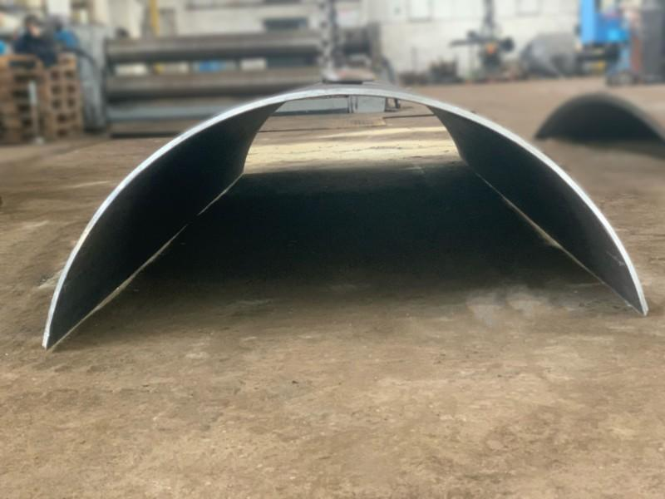
- Prepare a semicylindrical mandrel with the required radius and length.
- Measure the mandrel's semicircular cross-section using a ruler and measuring tape.
- Cut a flexible sheet of cardboard, plastic, or thin metal to the required dimensions.
- Position the sheet over the curved surface of the mandrel.
- Bend the sheet gradually around the mandrel.
- Align the two longitudinal edges with the diameter plane.
- Secure the sheet temporarily using clamps or fasteners.
- Prepare two semicircular end plates.
- Attach the end plates to the two open ends.
- Remove the mandrel if a self-supporting shell is required.
- Inspect the curved surface and adjust its shape.
This method is particularly useful for constructing semicylindrical shells and covers.

Construction Using Flexible Wire and Curved Ribs
# Source: AI Source: Provided by: [Data Path: Persons Table -> ID Column: 1, Name_En Column: Motasem Essam] -> From: [ChatGPT] on [7/25/2026]
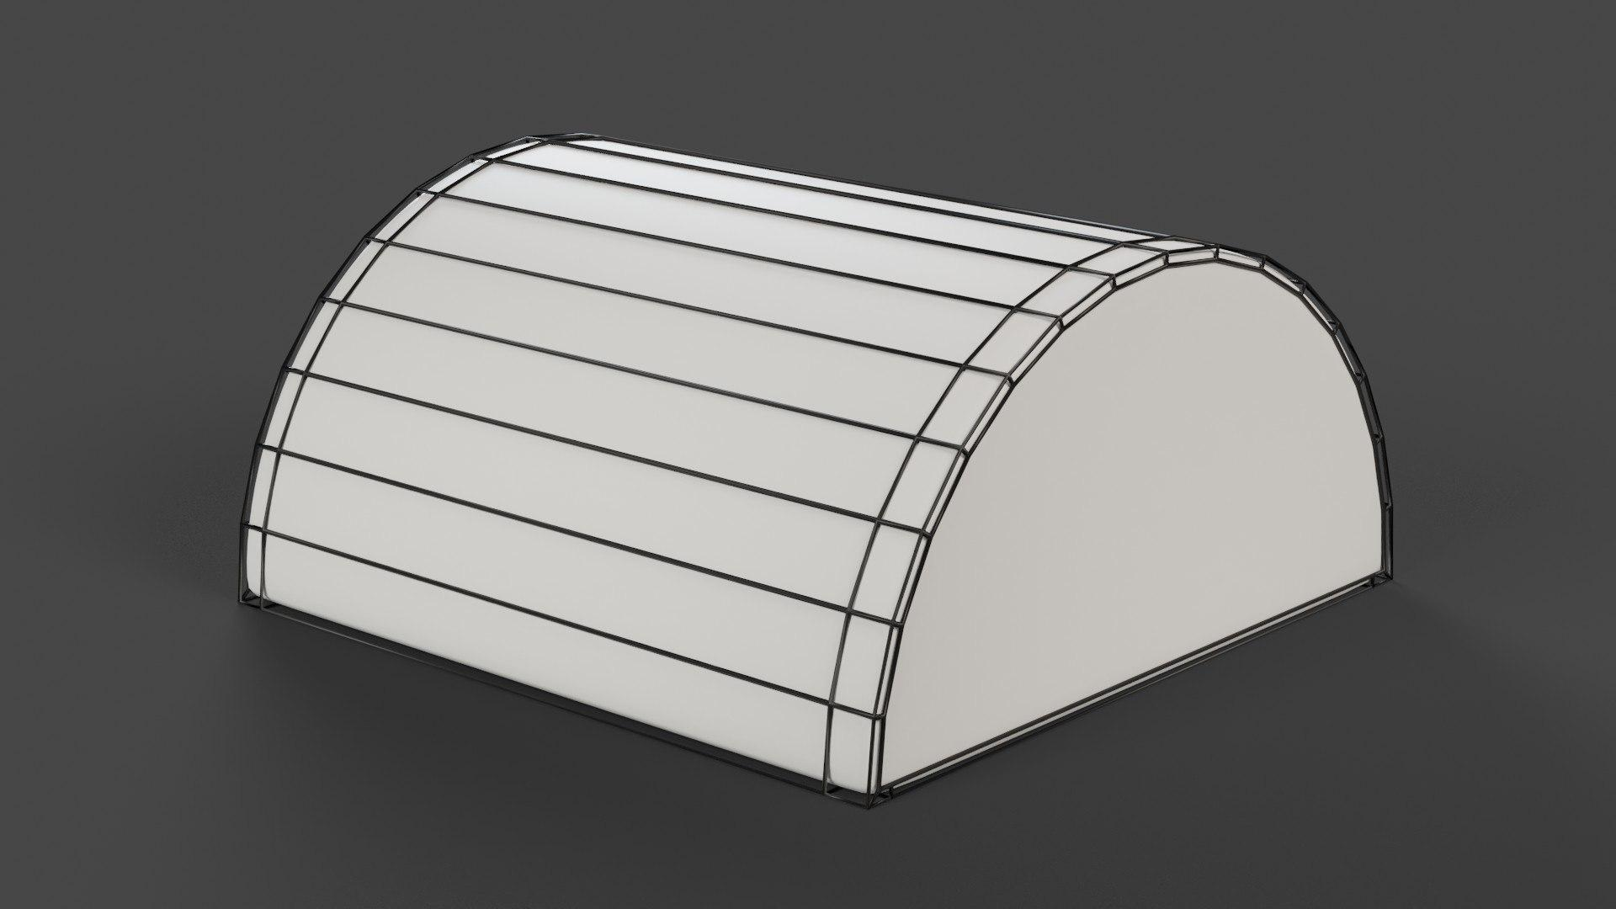
- Draw the semicircular end profile using a compass.
- Mark the diameter and required radius.
- Prepare two semicircular supporting frames from flexible wire or thin rods.
- Divide the semicircular arcs into equally spaced attachment points.
- Position the two frames parallel to each other at the required distance.
- Connect corresponding points using straight longitudinal rods.
- Add a straight supporting rod along each longitudinal edge.
- Check that all ribs form a consistent semicylindrical framework.
- Secure the connections using adhesive or fasteners.
- Cover the curved framework with a flexible sheet if a closed surface is required.
This method produces an open framework suitable for demonstrating the geometry of a semicylinder.

Construction Using Modeling Clay
# Source: AI Source: Provided by: [Data Path: Persons Table -> ID Column: 1, Name_En Column: Motasem Essam] -> From: [ChatGPT] on [7/25/2026]
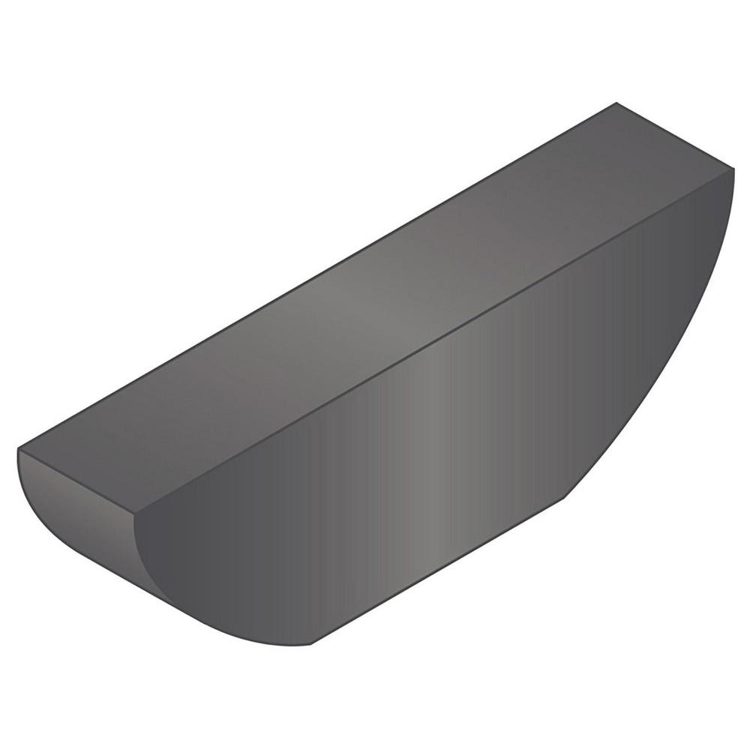
- Prepare a quantity of modeling clay.
- Draw a rectangle representing the flat longitudinal face.
- Mark the required length and width of the rectangular face.
- Form a solid clay body with a roughly semicylindrical shape.
- Use a semicircular template to check the end profile.
- Shape the curved upper surface using modeling tools.
- Flatten the bottom face to form a rectangle.
- Trim both ends so that they form matching semicircles.
- Smooth the curved surface and rectangular face.
- Verify the radius, length, and symmetry of the finished model.
This method is useful for producing a solid semicylinder without assembling separate components.

Construction Using a Mold
# Source: AI Source: Provided by: [Data Path: Persons Table -> ID Column: 1, Name_En Column: Motasem Essam] -> From: [ChatGPT] on [7/25/2026]
- Determine the required radius and length of the semicylinder.
- Prepare a mold with a semicircular cross-section and rectangular flat base.
- Verify the mold dimensions using a ruler and measuring tape.
- Ensure that the mold has two semicircular end boundaries.
- Apply a suitable release material if necessary.
- Pour plaster, resin, concrete, or another suitable modeling material into the mold.
- Allow the material to set or cure completely.
- Remove the semicylindrical solid carefully.
- Trim excess material around the edges.
- Smooth the flat face and curved surface.
- Inspect the finished model against the required dimensions.
This method is suitable for producing repeated semicylindrical models.

Construction Using a Paper or Cardboard Development
# Source: AI Source: Provided by: [Data Path: Persons Table -> ID Column: 1, Name_En Column: Motasem Essam] -> From: [ChatGPT] on [7/25/2026]
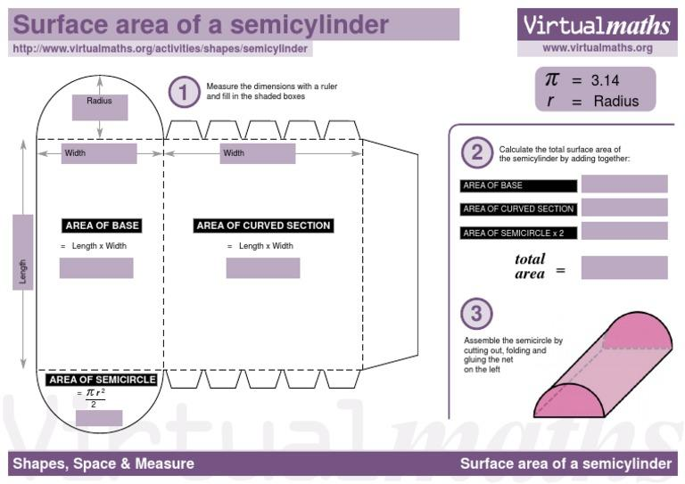
- Determine the required radius $r$ and length $L$.
- Draw a rectangle with dimensions $L×2r$ to represent the flat face.
- Draw a second rectangle with dimensions $L×πr$ to represent the curved lateral surface.
- Draw two identical semicircles, each with radius $r$, for the end faces.
- Add joining tabs around the required edges.
- Cut out all the components using cutting tools.
- Curve the second rectangle around a suitable semicylindrical support.
- Attach one semicircular end to each end of the curved sheet.
- Attach the flat rectangular face along the two longitudinal edges.
- Join the components using adhesive.
- Allow the adhesive to dry and inspect the completed semicylinder.
The development consists of one rectangle for the flat face, another rectangle for the curved surface, and two semicircular end faces.

Geometric Construction Notes
# Source: AI Source: Provided by: [Data Path: Persons Table -> ID Column: 1, Name_En Column: Motasem Essam] -> From: [ChatGPT] on [7/25/2026]

Main geometric characteristics
# Source: AI Source: Provided by: [Data Path: Persons Table -> ID Column: 1, Name_En Column: Motasem Essam] -> From: [ChatGPT] on [7/25/2026]
- Semicylinder: One half of a cylinder divided longitudinally by a plane passing through its axis.
- Semicircular Bases: Two identical semicircular end faces.
- Flat Rectangular Face: The longitudinal face created by the cutting plane.
- Curved Lateral Surface: The outer half-cylindrical surface.
- Radius: The radius of the original circular cylinder.
- Length: The distance between the two semicircular end faces.

Supporting formulas
# Source: AI Source: Provided by: [Data Path: Persons Table -> ID Column: 1, Name_En Column: Motasem Essam] -> From: [ChatGPT] on [7/25/2026]
VOLUME
$$V=\frac{1}{2}πr^{2}L$$
TOTAL SURFACE AREA
$$A=πrL+2rL+πr^{2}$$
CURVED LATERAL SURFACE AREA
$$A_{c}=πrL$$
FLAT RECTANGULAR FACE AREA
$$A_{f}=2rL$$
TWO SEMICIRCULAR END FACES
$$A_{e}=πr^{2}$$
Where:
- $r$ = radius of the original cylinder.
- $L$ = length of the semicylinder.

Main Construction Variants
# Source: AI Source: Provided by: [Data Path: Persons Table -> ID Column: 1, Name_En Column: Motasem Essam] -> From: [ChatGPT] on [7/25/2026]
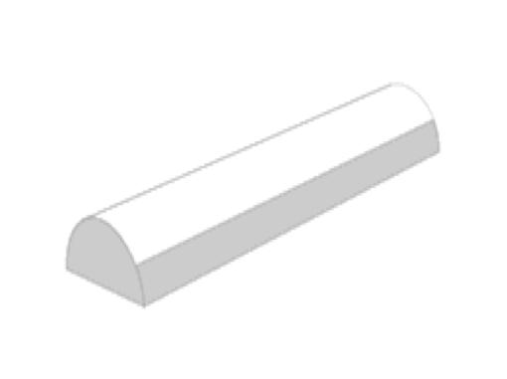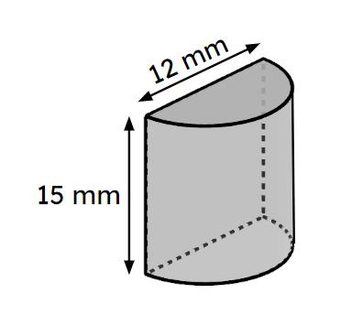
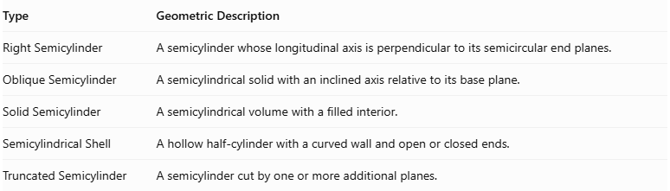
Type | Geometric Description
Right Semicylinder | A semicylinder whose longitudinal axis is perpendicular to its semicircular end planes.
Oblique Semicylinder | A semicylindrical solid with an inclined axis relative to its base plane.
Solid Semicylinder | A semicylindrical volume with a filled interior.
Semicylindrical Shell | A hollow half-cylinder with a curved wall and open or closed ends.
Truncated Semicylinder | A semicylinder cut by one or more additional planes.
Construction Note: These procedures use physical geometric instruments, semicircular templates, cross-sectional ribs, molds, and surface development. They do not use coordinate-based construction.

Geometric Characteristics
# Source: AI Source: Provided by: [Data Path: Persons Table -> ID Column: 1, Name_En Column: Motasem Essam] -> From: [ChatGPT] on [7/25/2026]
- It has two semicircular flat faces.
- It has one rectangular flat face.
- It has one curved lateral surface.
- Its cross-section perpendicular to its length is a semicircle.
- Its longitudinal cross-section through the central axis is a rectangle.
- It has two straight longitudinal edges where the rectangular face meets the curved surface.

Conclusion
# Source: AI Source: Provided by: [Data Path: Persons Table -> ID Column: 1, Name_En Column: Motasem Essam] -> From: [ChatGPT] on [7/25/2026]
A Semicylinder is a half-cylinder obtained by cutting a cylinder longitudinally through its central axis. It combines flat and curved surfaces and is characterized by two semicircular ends, one rectangular face, and one curved lateral surface.
It is commonly encountered in architectural structures, drainage channels, tunnels, and engineering designs.

